Docker Compose and Orchestration  
CS 470 Full Stack Development II

Sergio Mateos

Southern New Hampshire University

1. Text

   Description automatically generatedCreate a shared network.
2. Text

   Description automatically generatedCreate docker-compose.yml.
3. Text

   Description automatically generatedEdit server/datasources.development.js.
4. Text

   Description automatically generateddocker-compose up.

1. Graphical user interface, text, application, email

   Description automatically generatedDocker Dashboard app
2. Graphical user interface, text

   Description automatically generatedLoop Back

1. Graphical user interface, text, application, email

   Description automatically generatedStored

**Front End**

1. 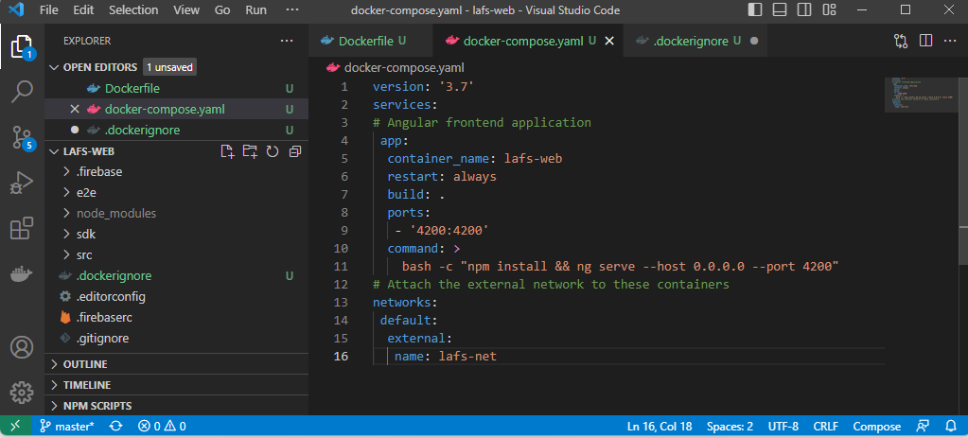docker-compose.yml.
2. 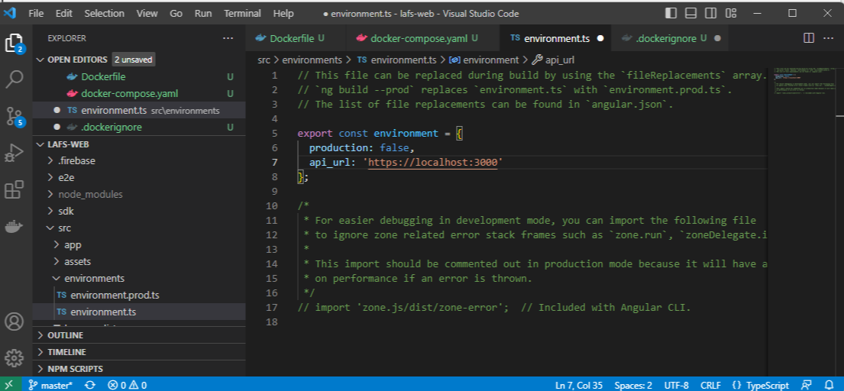api-url.
3. Background pattern

   Description automatically generatedQuestion
4. docker ps -a

